**AWS Cloud practitioner**

**Cloud computing**

It is a service that allows users to use the online services and access the online resources from anywhere in the world through internet.

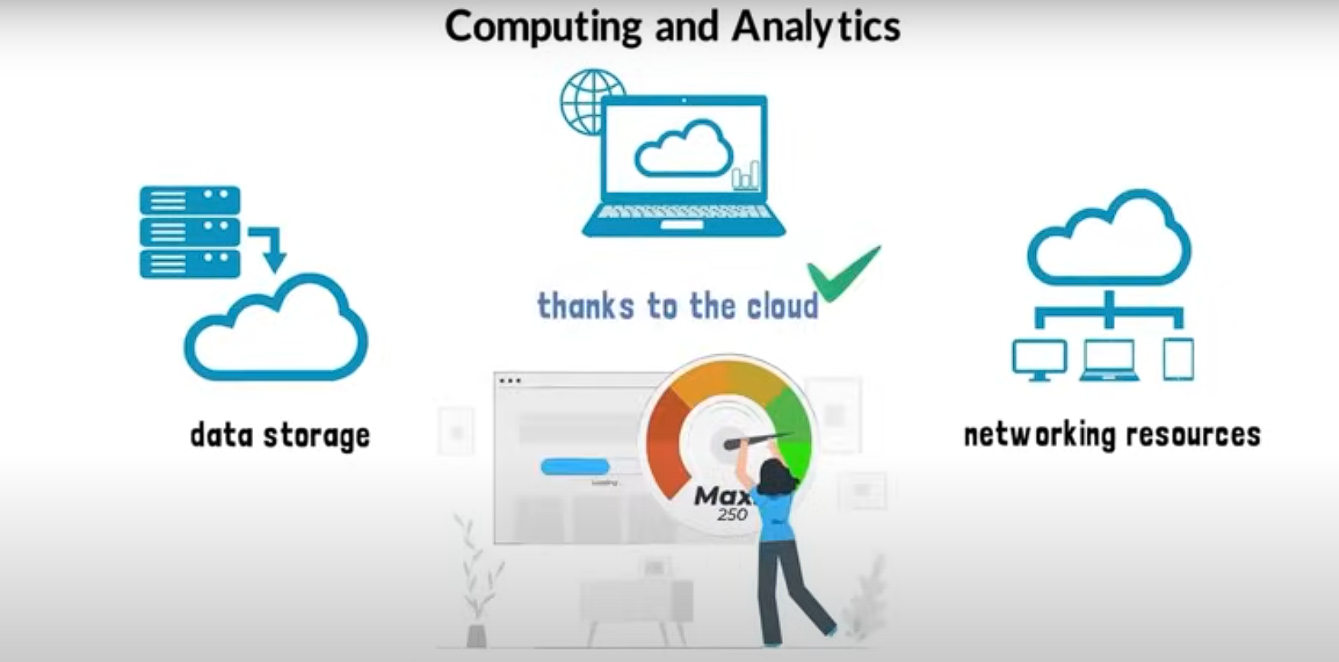

Goal of cloud computing is to deliver the services and faster innovation with the flexible resources.

**Cloud computing**

Cloud computing is :

* Storing data/applications on remote servers
* Processing data/applications on servers
* Accessing data/applications via servers

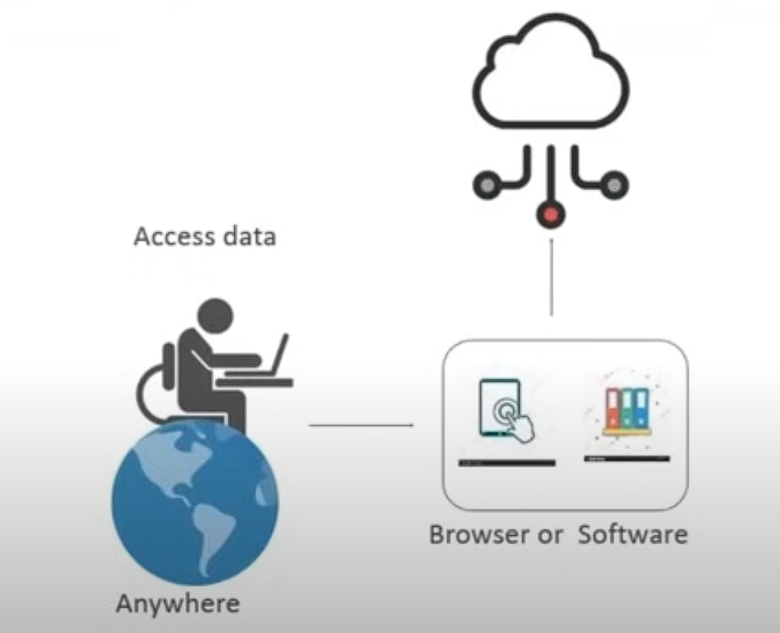

**Service models**

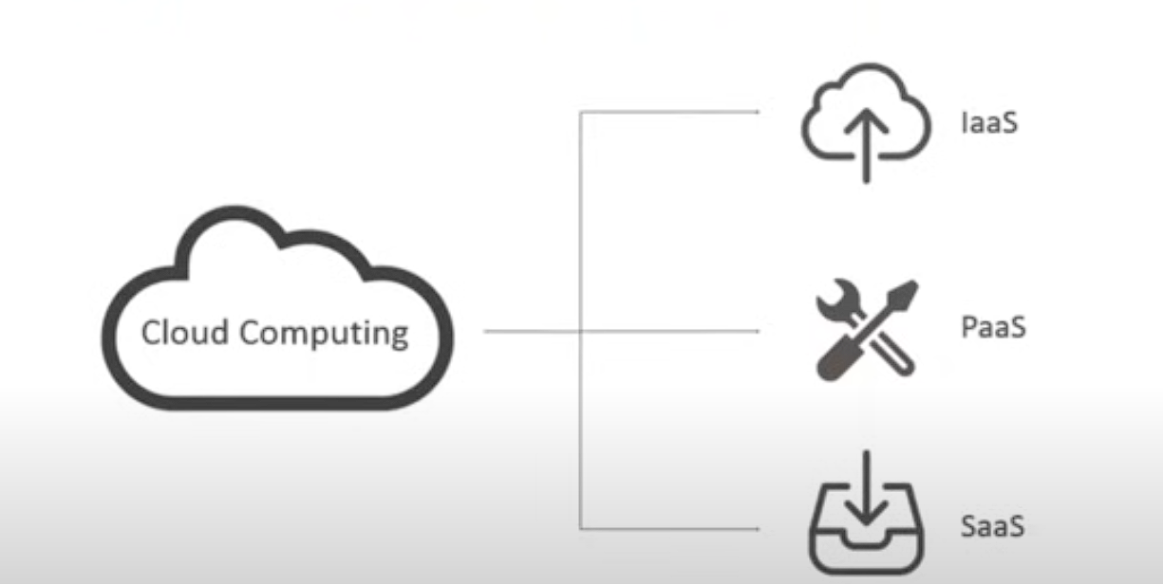

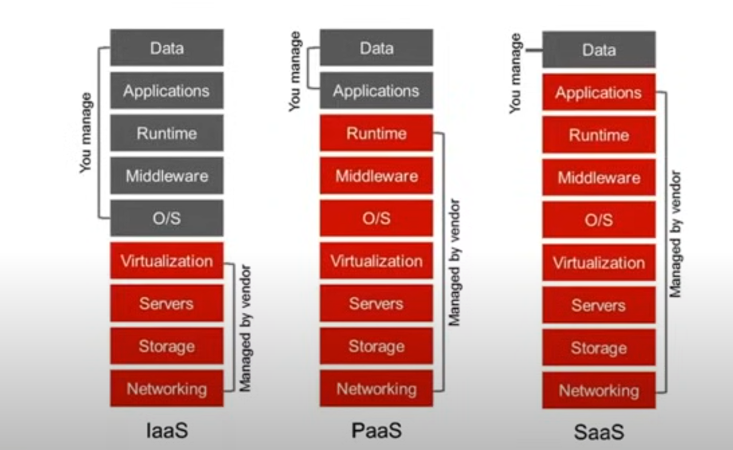

**Deployment models**

* Public cloud
* Private cloud
* Hybrid cloud

Public cloud: It is the cloud that can be accessed by everyone/anyone to get the services that an organization or a company offers.

Private cloud: Here, this cloud can be accessed to few people so that make the security concerns go away and we can build our own applications.

Hybrid cloud: It can used when the traffic of the site or the service is not much regularly and could be shifted to public when the traffic is high and shifts to private cloud when traffic is low.

**Amazon Web Services**

AWS is a secure cloud services platform that can provide compute power, database storage and content delivery and other functionality to help businesses scale and grow.

**Features of AWS**

* Flexibility
* Cost effective
* Scalability
* Security

AWS infrastructure is divided into following catagories

1.Avalability zones (Data centers)

2.Regions

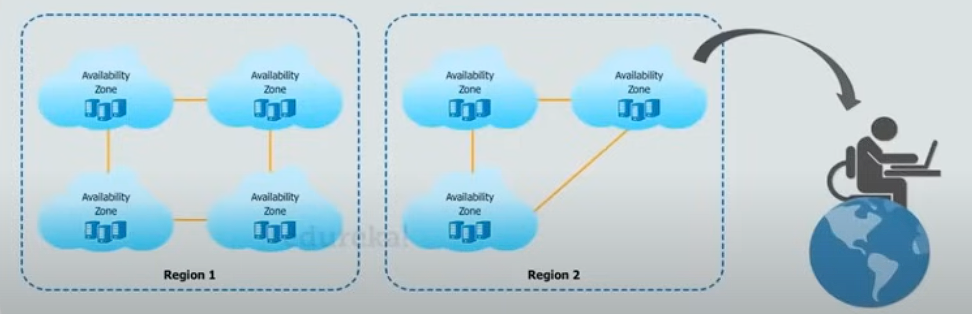

**Domains of AWS**

1. Compute(EC2, Elastic beanstalk(pre-isntalled libraries))
2. Migration
3. Security and compliance
4. Storage (S3, Glacier(archives))
5. Networking
6. Messaging
7. Databases (Aurora, SQL, Dynamo DB)
8. Management tools (Cloud watch)

**Instance**

It is an virtual server that is used for running applications on Amazon’s EC2

Which offers hardware, network connection, OS, etc.. all virtually.

**What is EC2.**

Amazon elastic cloud compute is the web service from amazon that provides Re-sizable compute services in the cloud.

* Scalable
* Cost efficient
* Flexible

**Types of instances**

1. General purpose instance (Balance performance and cost)
2. Compute instances (Applications that need lot of processing and CPU)
3. Memory instances (heavy applications, Multi processing)
4. Storage instances (Applications that are huge in size/data)
5. GPU instances (heavy graphics applications)

**Pricing Models:**

**EC2 instance**

* On-demand
* Dedicated
* On-spot
* Reserved

**Based on the functioning**

* Burstable (Can be used for type of applications when we don’t know the performance)
* EBS optimised (High input and output processing)
* Cluster networking (Different parts with multiple functionalities)
* Dedicated (Dedicated for single kind of processing till the end)

**Use case**

* Analysis (Burstable instance)
* Response (EBS optimized instances with IOPS)
* SE & Browsing (Clustered instance)
* Confidential (Dedicated instance)

**Create windows instance using custom AMI from catalogue:**

* Open EC2 instance and go to AMI catalogue
* Search for the windows free tier AMI using filters on the left of the screen
* Then select the windows AMI with the free tier option and start setting up the instances

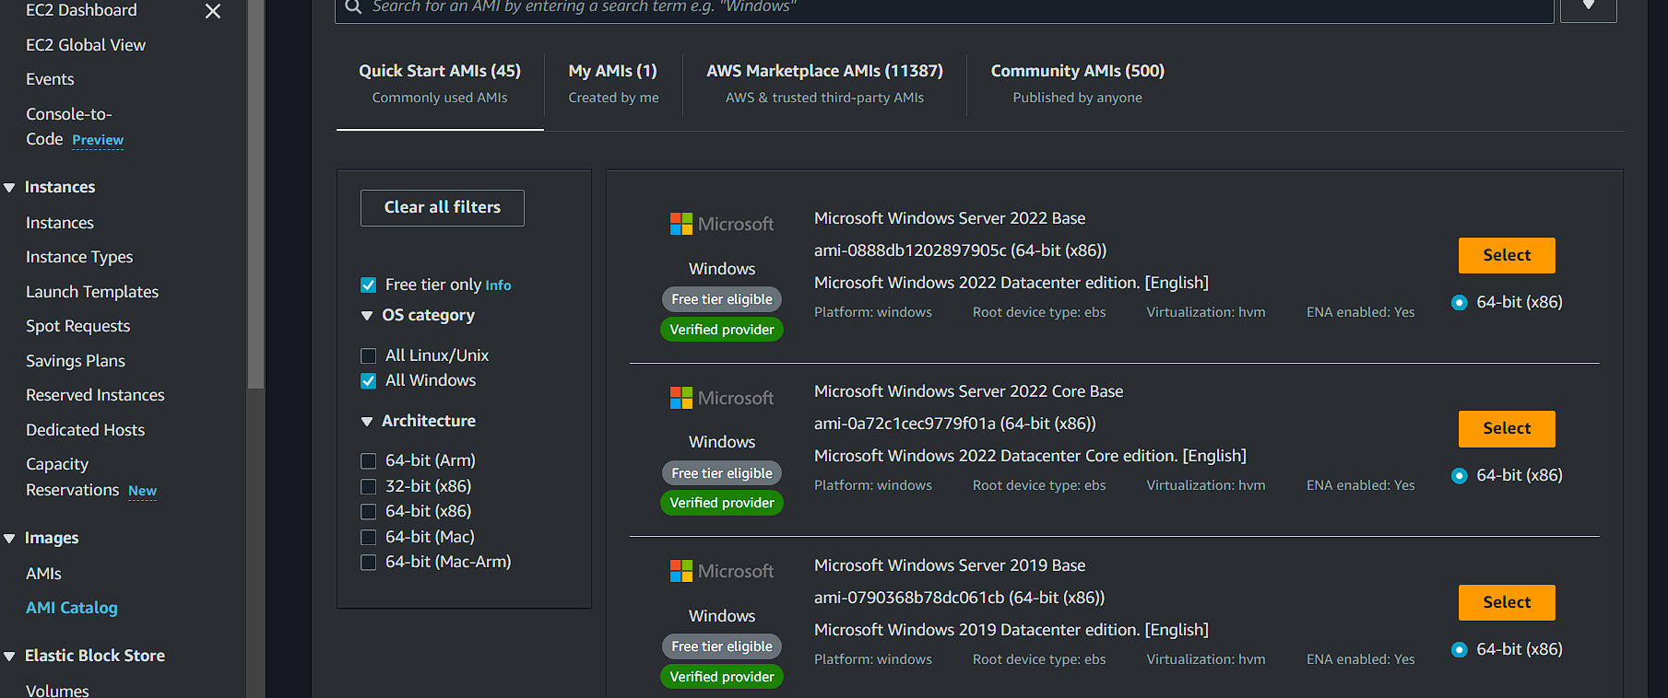

* Now start creating the instance by selecting the AMI from the returned results

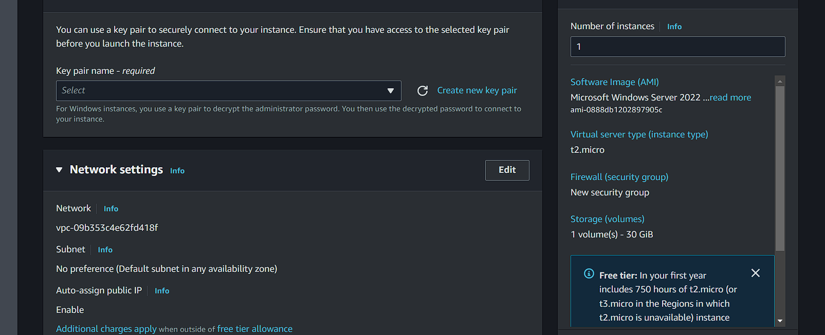

* Create a keypair and download in the .pem format and save in a noticeable folder.
* Then change the network setting from create security group to select existing security group.
* Then select the security group shown in the image

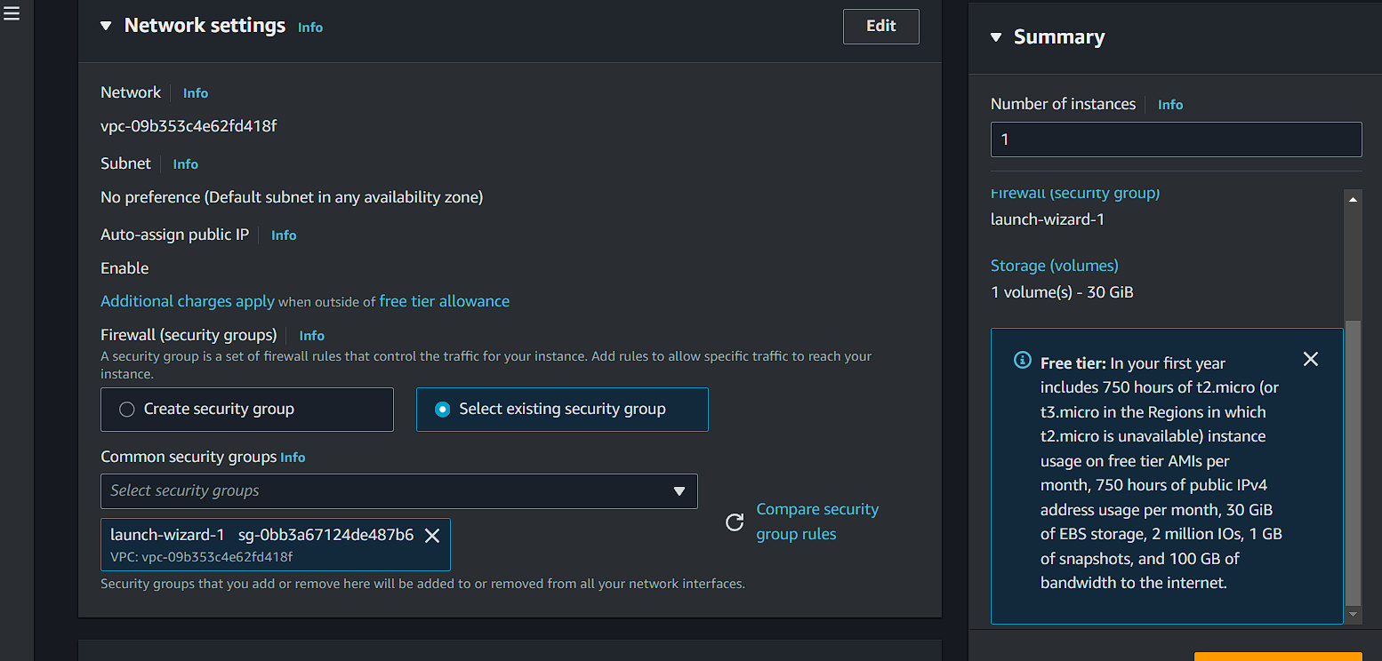

* After selecting, launch the instance.

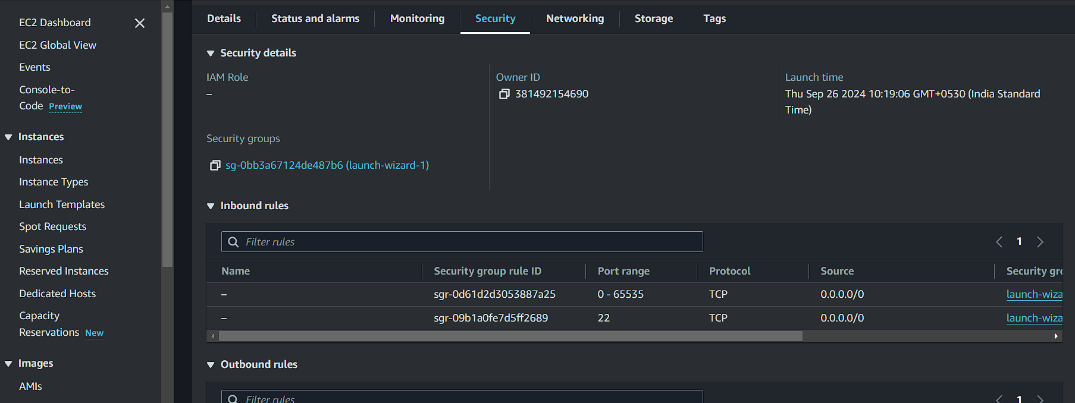

* After launching open the instance and the go to security details and then inbound rules.
* Select an inbound rule and click on launch-wizard then click on the ID that was shown after clicking the launch-wizard.

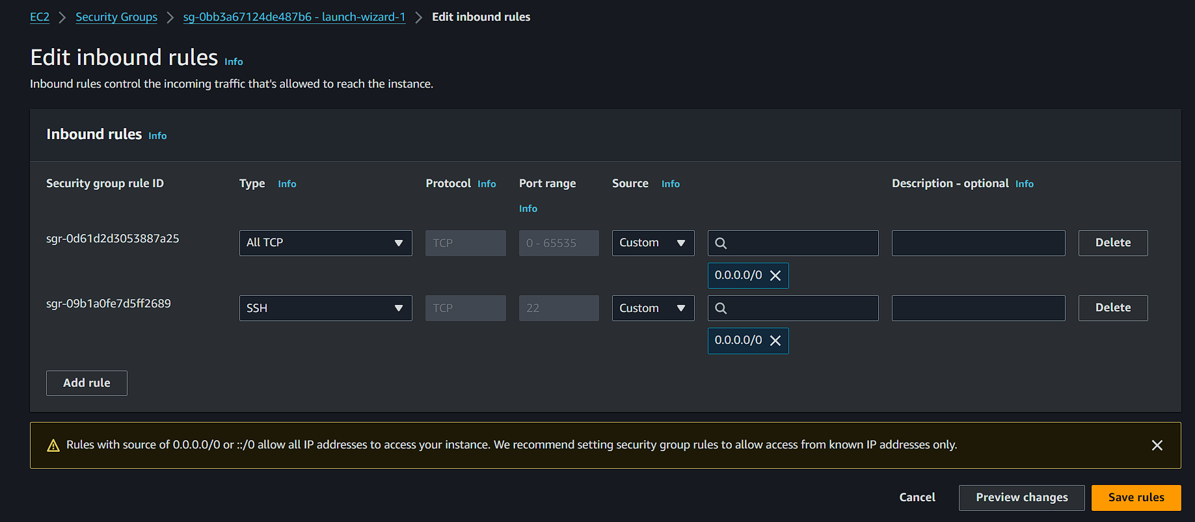

* After clicking, edit the type of inbound to ‘ALL TCP’ port range should be higher to get the server to run.
* Then save the rules and return to instances then click on connect.

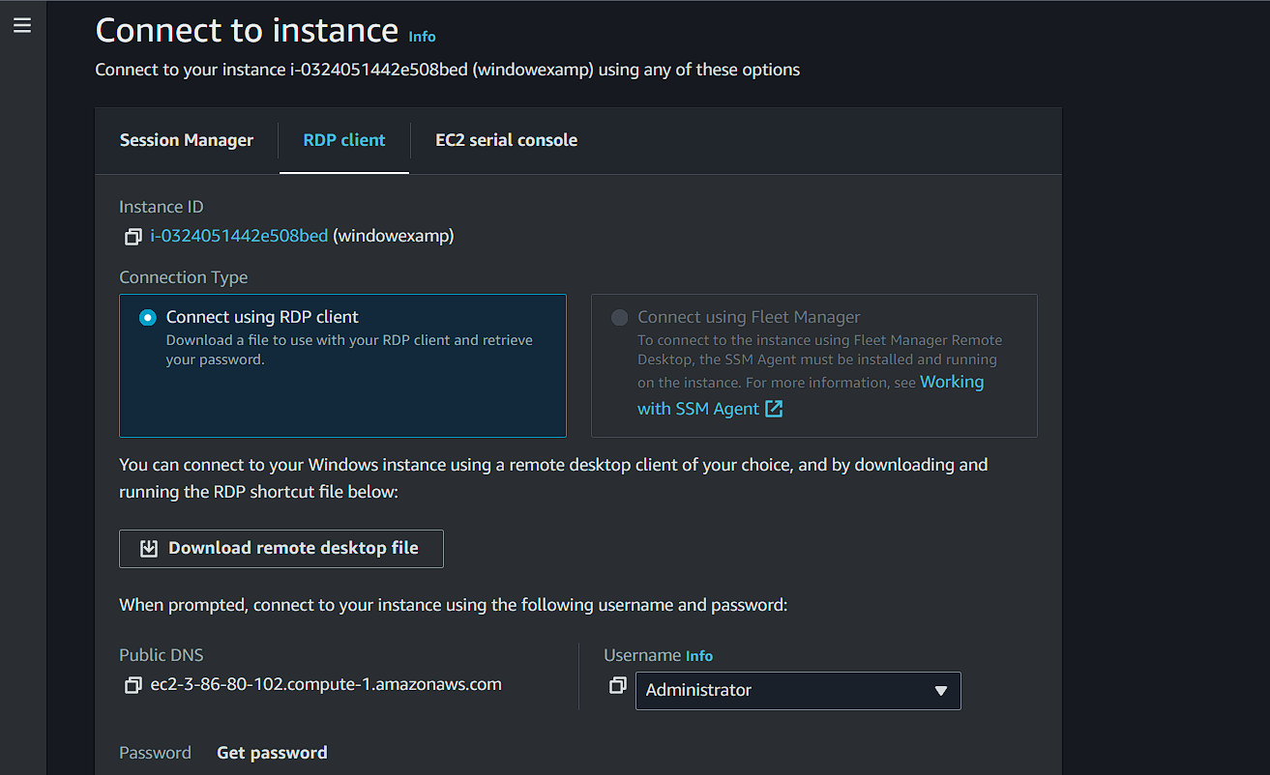

* Go to RDP client after clicking connect option.
* Download the remote desktop file and save it to use later.
* Then click on get password, upload your ‘.pem’ file and start decrypting and get the password.
* Now, click on the remote desktop file that we have downloaded before.
* Enter the password we have got from the get password.
* You can see the screen as show in the picture below and allow the and go to next steps to launch the windows OS.

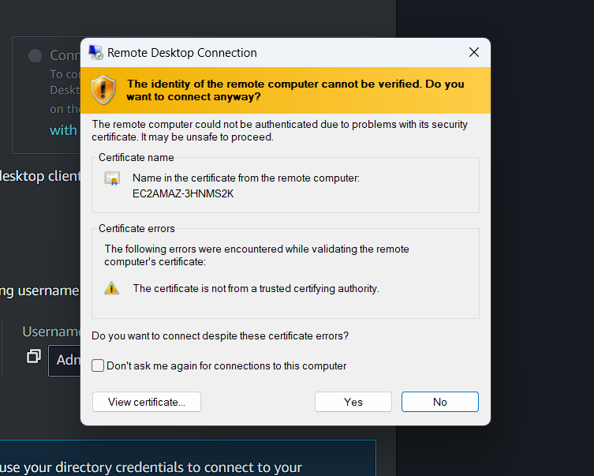

We have successfully created a Virtual window operating system.

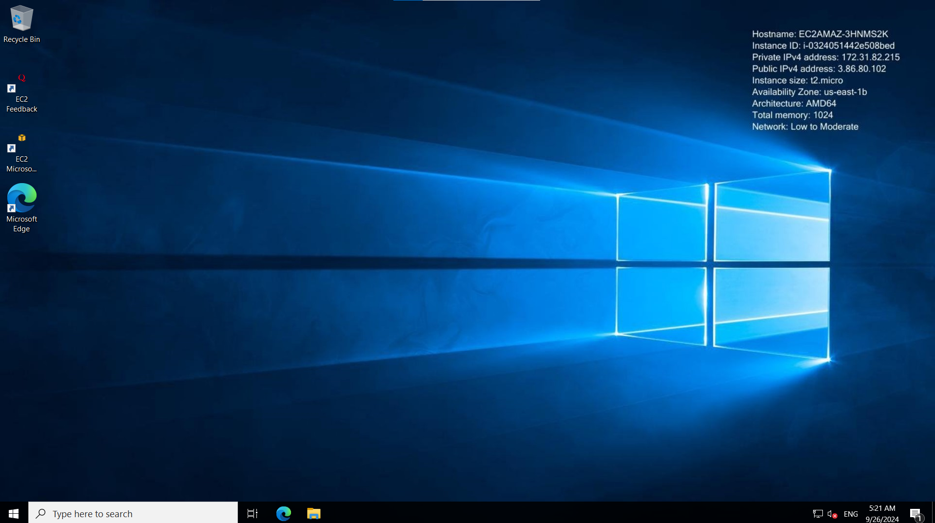

**AWS Lambda:**

AWS lambda is a serverless services, where developers don’t need to worry about which AWS resources to launch and manage them.

* Used to execute the backend code
* Managing includes updating, patching updates, scaling, terminating, stopping.
* The code that we want lambda to run is called lambda function.

Example:

If we want to update the image into the server the image needs to process some information about the image, that process can be triggered when the image was uploaded and the lambda function will be triggered. This is the use of lambda function.

* The invoke call from the S3 bucket will triggers the lambda function
* The execution role in the lambda function is called as IAM (identity and Access management) to give permission to S3 bucket resources.

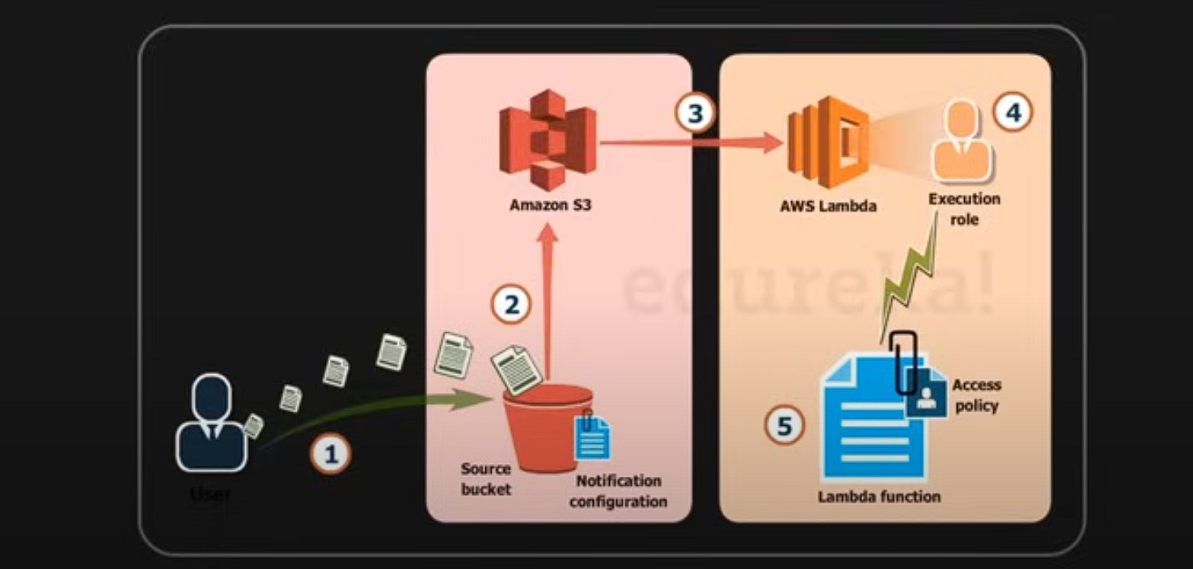

* AWS lambda is compatible with nodejs, python, java, etc.
* To use this, we need to upload an zip file and define the event source.

**AWS lambda vs other compute services:**

* AWS ops and AWS bean-stalk is used to deploy an application
* EC2 is also used to execute the backend code.
* For EC2 we have set up everything from load balancer, EBS volumes, Software stacks, etc.
* But in AWS lambda we don’t need setup all these, we just need to upload the code and the AWS will manage all other things needed for computing.
* If the applications get continuous requests and long server times it is best to go with EC2.
* Architecture of lambda is used for the less requests and sometimes it can manage high requests but not frequently.
* AWS lambda can be used for the small companies that are having just limited time of activity and free time as much as activity and sometimes there will very less activity

**Creating a lambda function:**

* Go to AWS homepage and search Lambda and click open it.
* Then click on the create new function
* Name the function and define the language that the function going to handle.

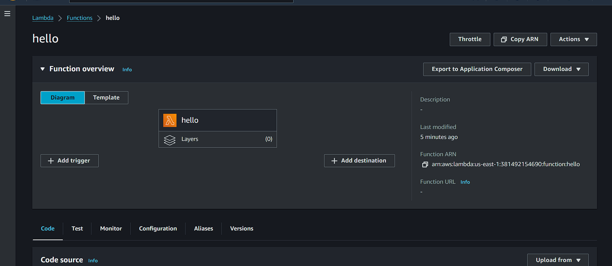

* Then open the function created and you see a example code in python in the console.
* There we are going to upload our code.
* Trigger is the revoking point that could get the lambda functions live when the requirements were satisfied
* Layers are the libraries that can be used to run the function we just simply needed to setup them to run the functions.

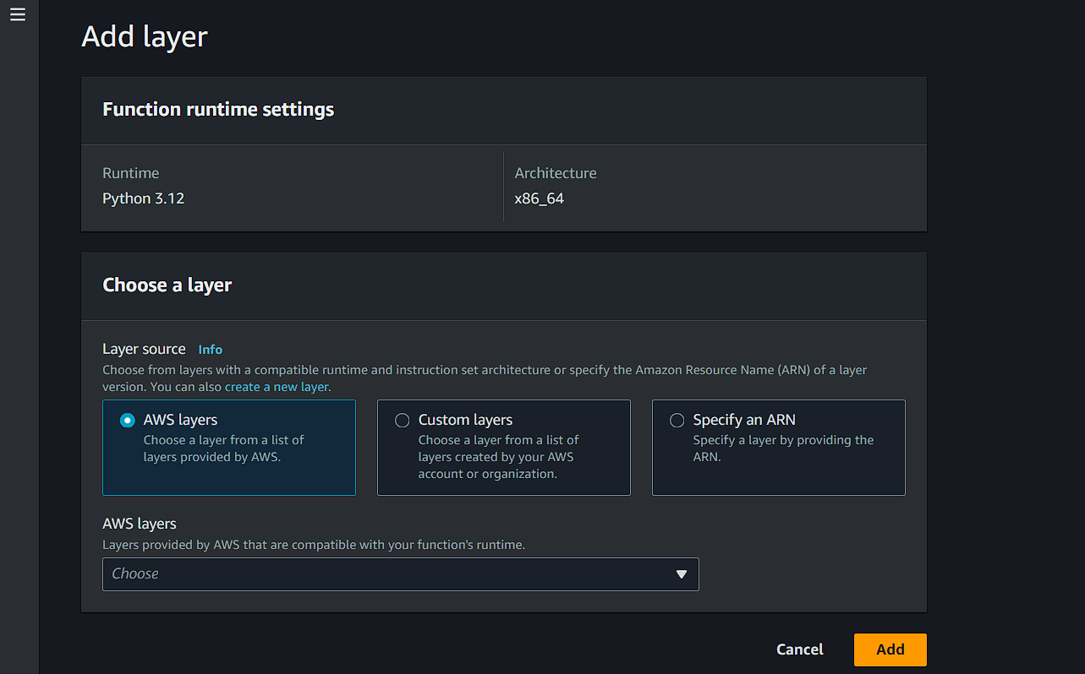

* AWS layers are the suggested layers that can be added to the program so that the function could run efficiently.
* Custom layers are the layers that are created by us so they are customized and setup accordingly.
* ARN (Amazon resource name) is the type of layer that was created by another account and doesn’t match your function run time/details.
* Destination is the area where the record of invocation after success or failure of a function.
* When can use the destination when the function was invoked asynchronously.

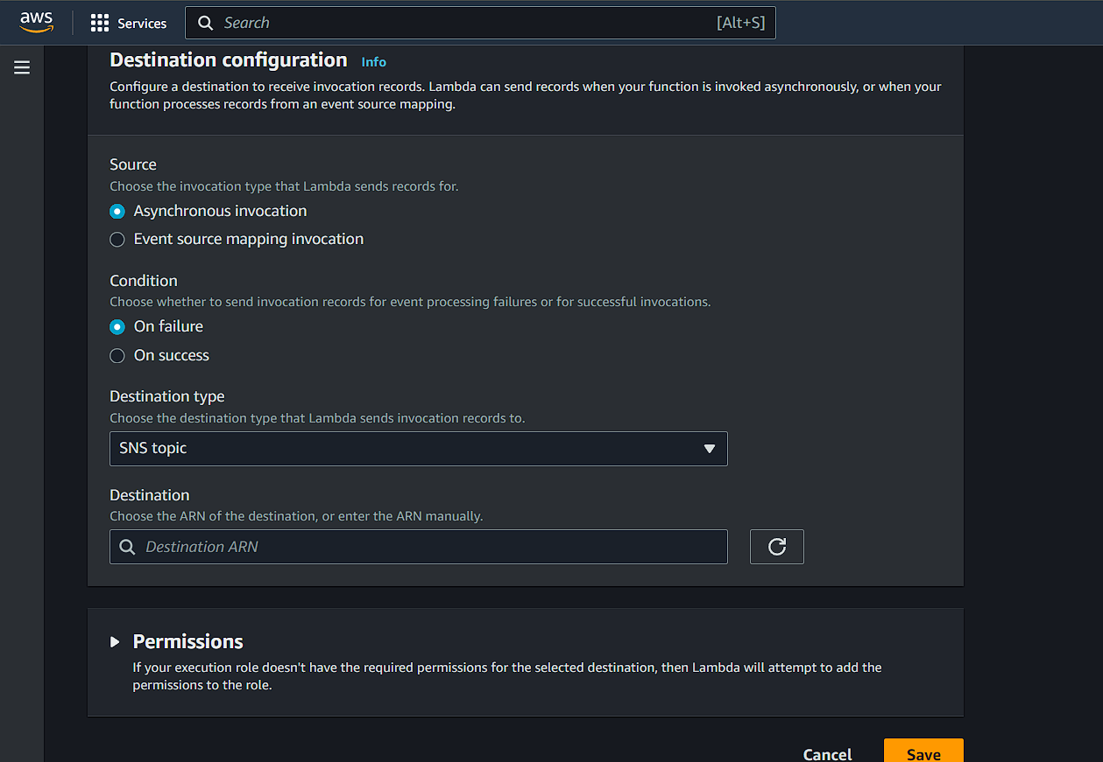

* Now scroll down to console and click on test dropdown and it shows create test-event.

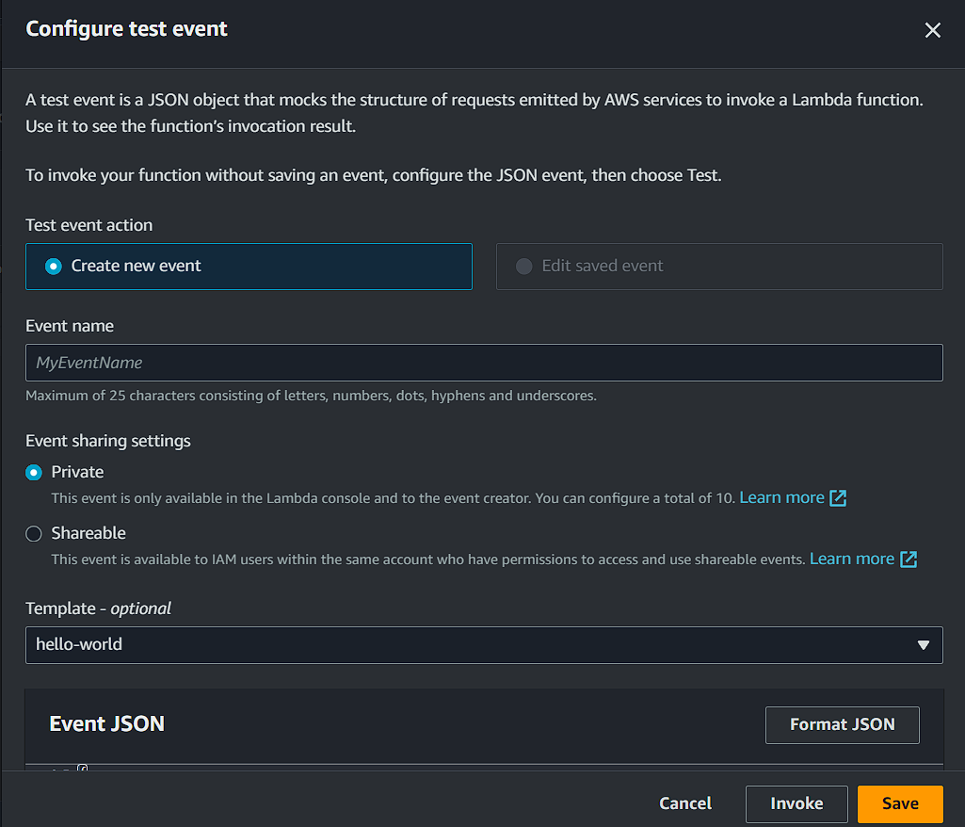

* Name the event and click create.

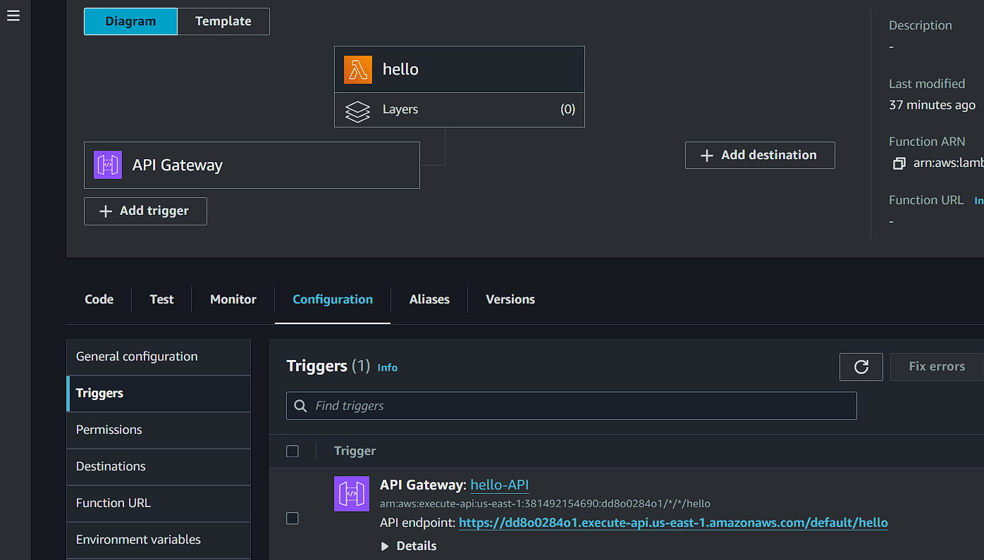

* By creating an trigger we can get the output in the page .
* Go to add trigger and select the API gateway and select create new api then use the HTTP as the service.
* Click create, the trigger was created and ready to be live.
* Click on the trigger showing and open it, click on the link corresponding to API endpoint.
* Use that link and open and see the output.
* In the end delete the lambda function.

**Elastic Beankstalk:**

AWS beanstalk is an PAAS used for deploying and scaling web applications and services developed using the JAVA, PHP, .NET, etc. on familiar server such as apache, nginx, tomcat.

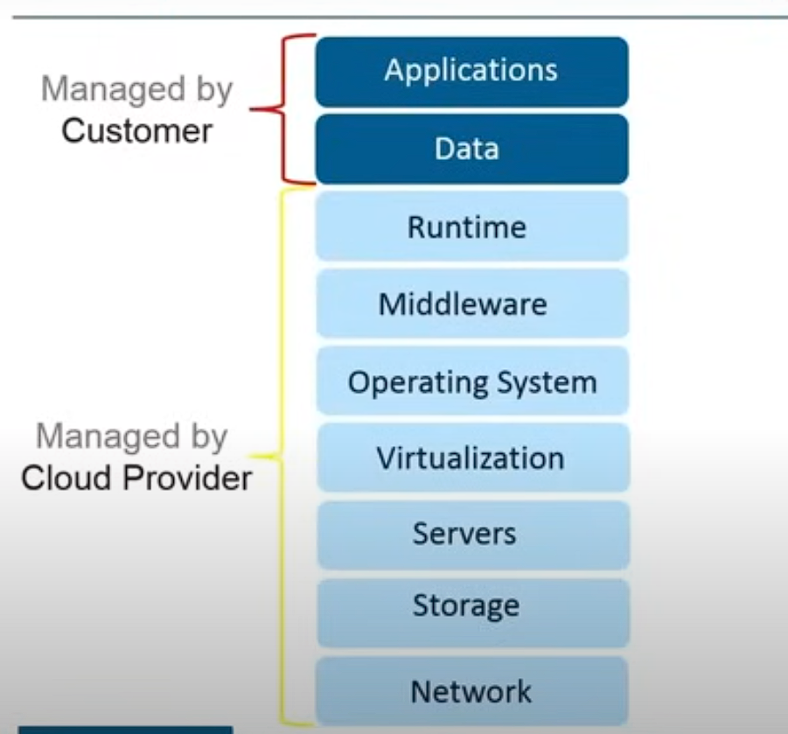

**Advantages of AWS elastic Beanstalk:**

1. Quicker deployment
2. Simplifies operations
3. Cost effectiveness
4. Multi-tenant architecture
5. Better user experience

**Features of elastic beanstalk:**

* Fast and simplest way to deploy the application
* Manages the operations without user worrying about them
* Automatically scales the application based on specific needs
* Gives freedom to select the AWS resources

**Components of elastic beanstalk:**

Application version: It refers to specific, labeled iteration of deployable code for a web application

Elastic beanstalk helps the application to enroll updates without deleting the previous ones and sets and sends as versions to web.

Environment: It is place where the application is being run and each environment runs only single application.

In elastic beanstalk the environment can be able to run the multiple applications.

Environment tier:

Environment health:

**Architecture of elastic beanstalk:**

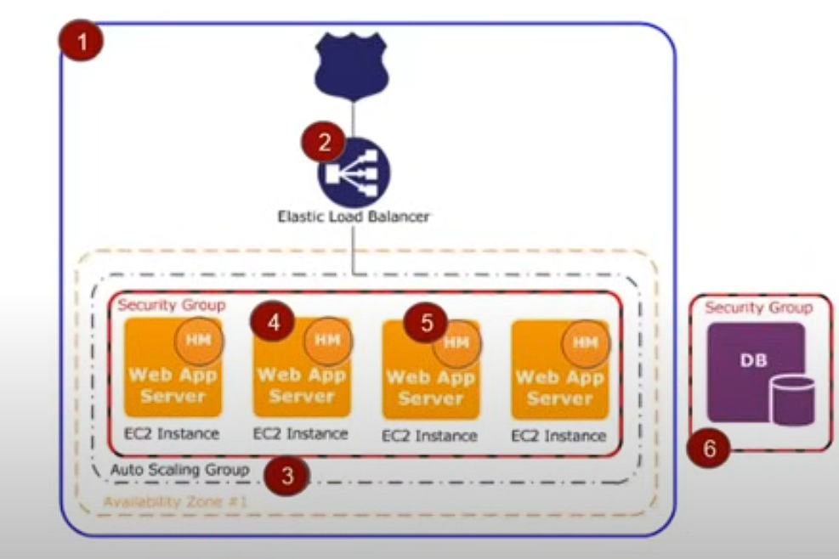

* Beanstalk asks us to choose between few servers where we need to perform our operations.

**Web server environment**

* Beanstalk environment
* Elastic load balancer
* Auto scaling group
* EC2 instances
* Host managers
* Security groups

**Worker environment**

When a webserver got requests from the client and those requests consists of high time taking and resource taking and cant be able to get to the other actions because its busy in doing a task.at that time the server allocates the work to the worker environment so it can able to handle or receive other requests.

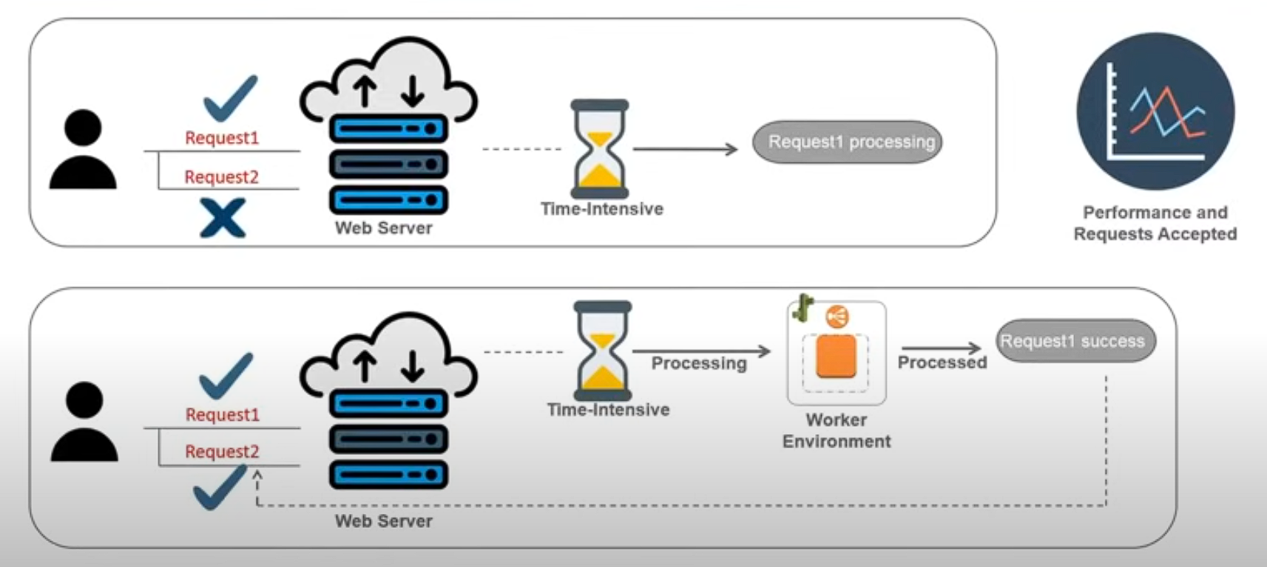

**How does environments communicate with each other.**

* By using SQS message (simple queue Service by amazon)
* The message will be sent to SQS queue

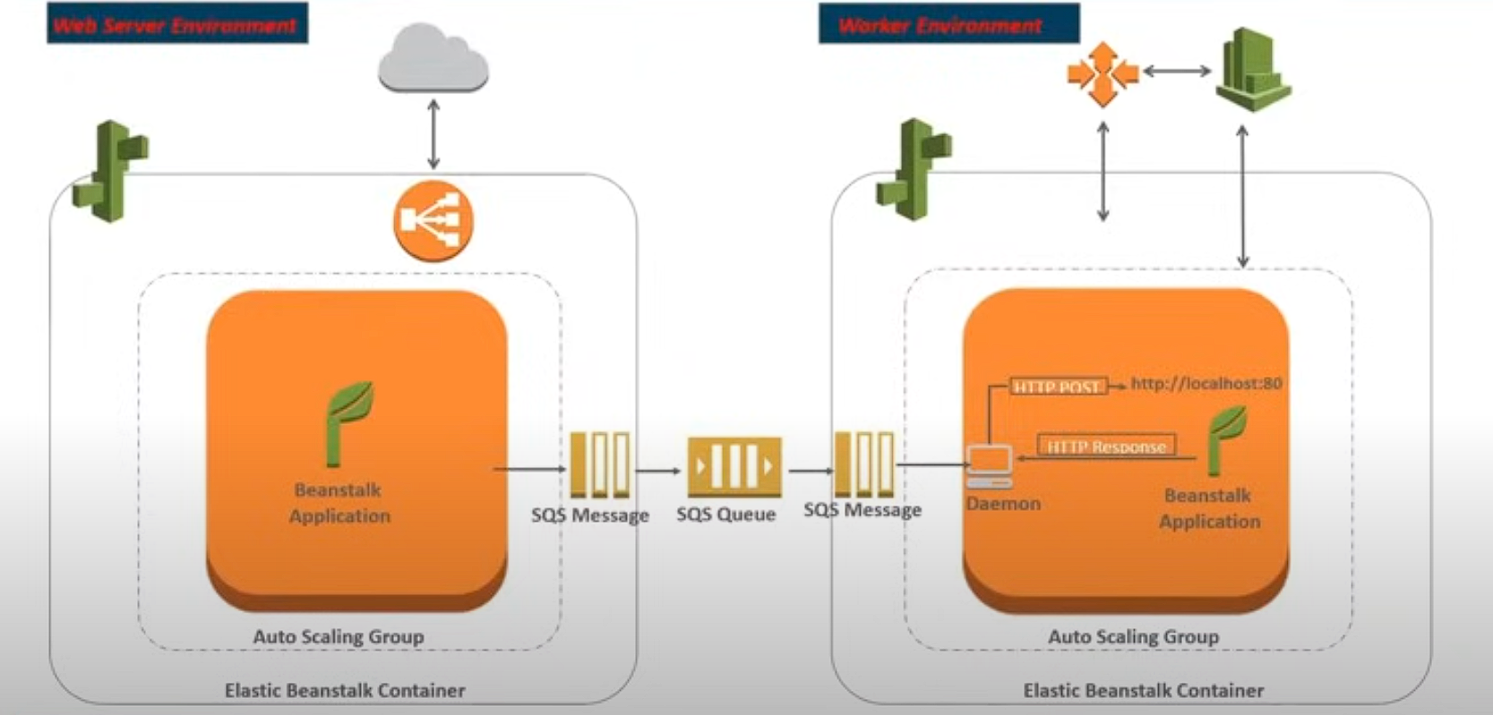

* In the worker environment there is daemon that takes the SQS message from SQS queue.
* Sends the tasks that is running in the local host
* Then after that the beanstalk application starts processing.

**Elastic beanstalk deployment**

* To launch a elastic beanstalk application
* The user need to sign in to AWS and search for Elastic beanstalk service and open by clicking on it
* Then the user need to click on create application and the creation of application starts
* Here the user can configure the application based on the need of the user and the organization
* User firstly, need to setup the name and the type of the application they want to launch like web server or worker environment
* Then user starts configuring the monitoring and networking tools that’s could help in monitoring and sharing the application to the future use
* Then the user can opt to the free tier or the paid based on their interest
* Here on the instance groups and regions that need to user to run the application will be configured and in the end the user will take able to launch the application that runs efficiently and
* User can monitor the health of the application by visiting the dashboard and there will events that generates every second so the user can get the brief about the application state.

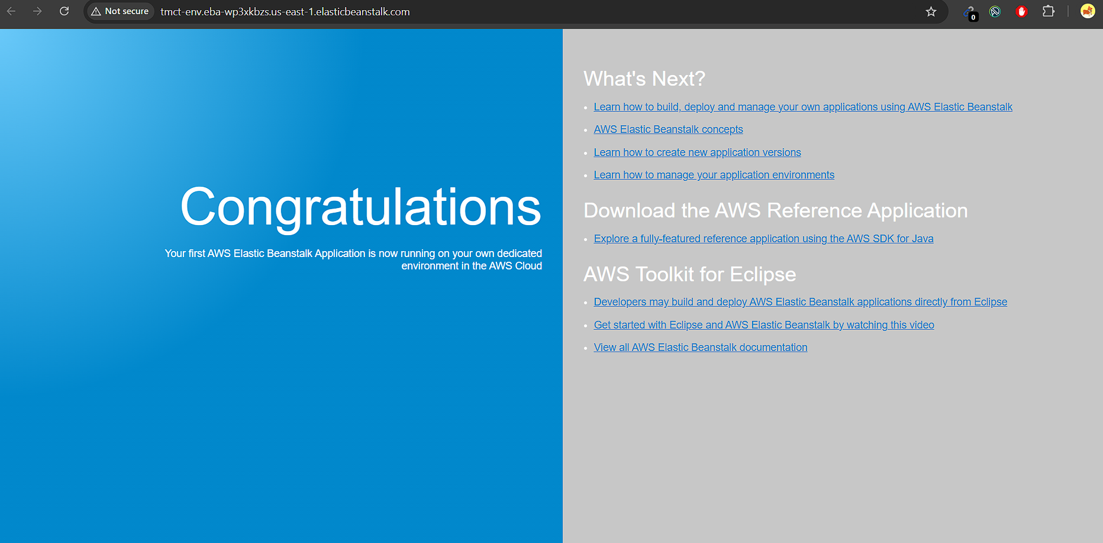

You will able to see after clicking the link that was provided after the launch of the application. It is a demo application that was launched by using the beanstalk application.

We can upload new versions by naming them and following description while releasing it publicly

Multiple versions can be managed through out the process and all applications can be shown in the stalk dashboard.

**Cloud storage practices:**

* Scrutinize SLA (know the priority of service for organization and select as per need)
* Follow your business needs (Based on data we need to select the service)
* Ensure security
* Plan the storage future (Select based on the future scaling and traffic income at a particular time of the day)
* Beware of hidden costs (Always check for hidden costs in the case of increasing costs in future)

Cloud storage providers:

* Google cloud platform
* Digital ocean
* IBM cloud
* Terremark
* AWS
* Microsoft Azure

**Storage in AWS**

* S3 (Simple storage service)
* EFS (Elastic file storage)
* FSx
* S3 glacier
* Storage gateway
* AWS backup

Storage gateway is helpful on sending the data to the cloud that was present in the DB or the bucket.

**AWS S3:**

Amazon s3 is a simple web service interface that you can use to store and retrieve any amount of data, at any time, from anywhere from the web.

Features:

* Durable (uses checksum to analyse data )
* Flexible
* Available
* Cost efficient
* Scalable
* Secure

Amazon s3 works with the concepts of objects and buckets

* Bucket is the container and the object is file that was stored in the container
* Objects has metadata

S3 storage classes:

* Standard (latency period is less)
* Infrequent access (For longer usage and quick retrieval)
* Glacier (Retrieval is slow and data need to be stored longer duration)

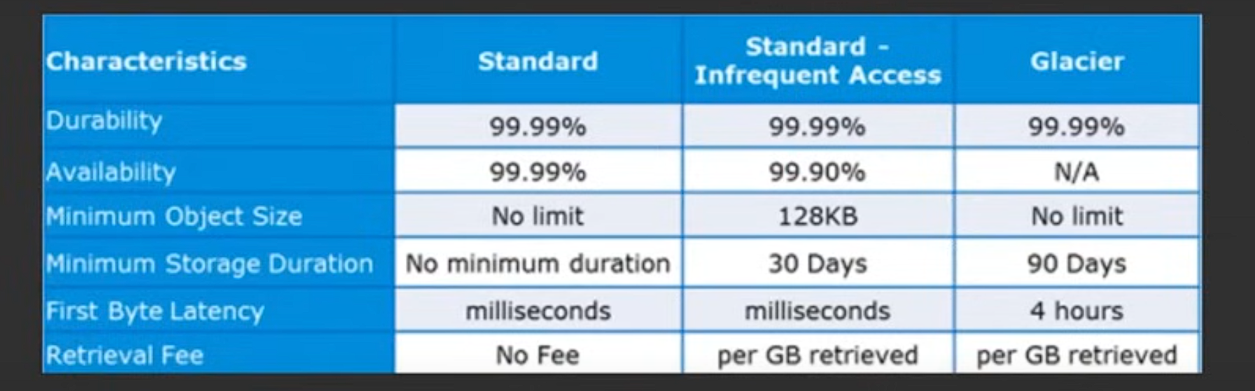

**Versioning and cross region replication**

* Prevents overwriting or accidental deletion
* Get non concurrent version by specifying version ID
* Enables automatic, asynchronous copying of objects across in different AWS regions.
* Buckets configured for cross-region replication can be owned by the same AWS account or by different accounts.

**S3 transfer acceleration:**

* Enables fast, easy, and secure transfers of files over long distances between your client ad a S3 bucket.

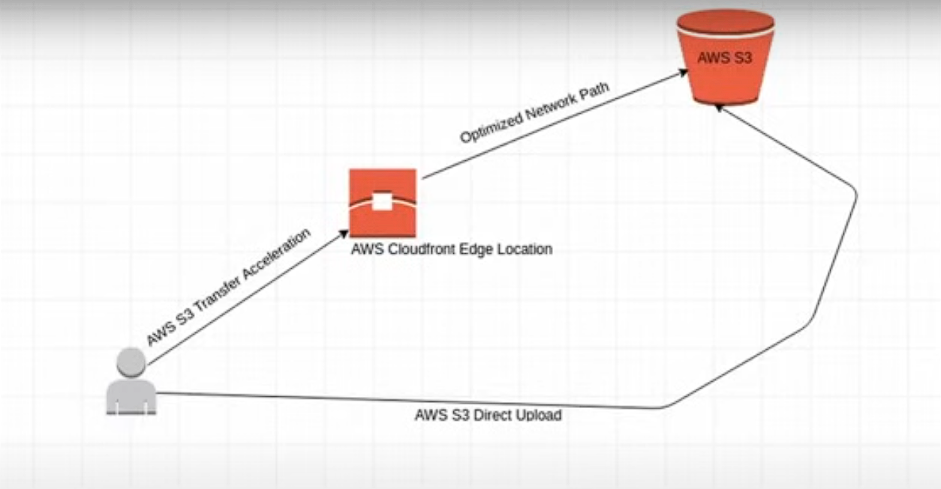

* It can be done caching or storing the data near to the S3 bucket so it can be easily transferred.

USE CASEE: IMDB media

* For all possible results for a search are pre-calculated with a document for every combination of letters in search.
* Each document is pushed to S3 and there by amazon cloudfront, putting all documents close to the user.
* But in practice using IMDB’s authority on movie and celebrity data can reduce the search space to about 150,000 documents, Amazon S3 and cloudfront can distribute in few hours.

AWS networking fundamentals:

* Amazon VPC (virtual private cloud) is service that lets you launch AWS resources in a logically isolated virtual network that you define.
* This VPC can be accessed by you and no one either you are AWS itself can access but can’t accessible to the public.
* Amazon VPC helps to build multiple security layers including security groups and access permissions and network rules.
* Subnets are logical subdivision of a larger network.
* Public and private subnets have different qualities like resources are public and admin area will be private.
* Route table contains set of rules called routes that allows traffic from your VPC is directed.
* **Elastic load-balancer** automatically distributes your incoming traffic across multiple targets such as EC2 instances, containers, IP addresses, in one or more availability zones.

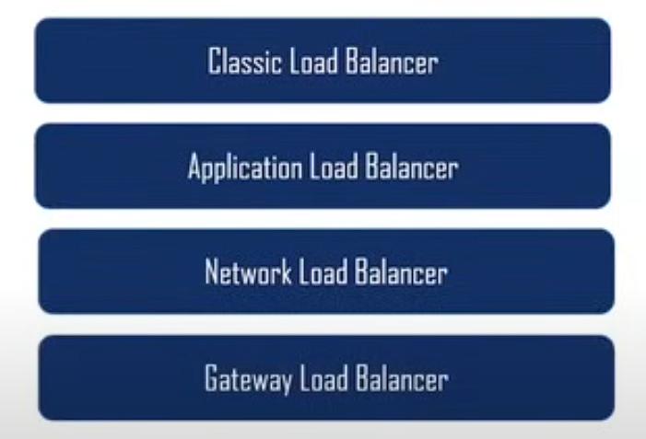

* **AWS direct connect** is a cloud service that makes it easy to establish dedicated network connection from your premises to AWS.
* **Amazon Route 53** is a highly available and scalable cloud domain name system or DNS web service.

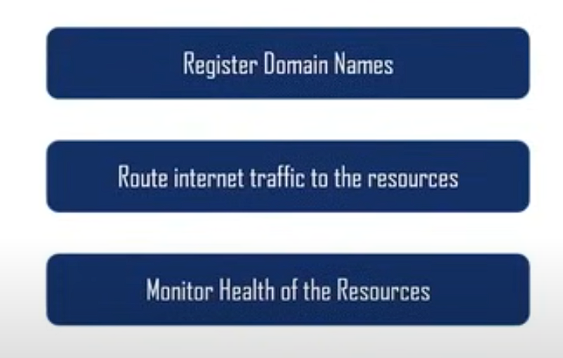

**Creating a VPC**

* Go to AWS and search for VPC and click on it and then click on my vpc

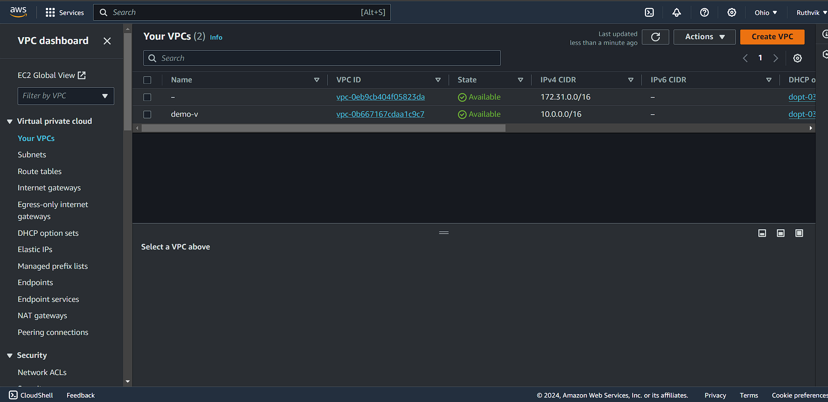

* Now start creating a VPC by Create VPC

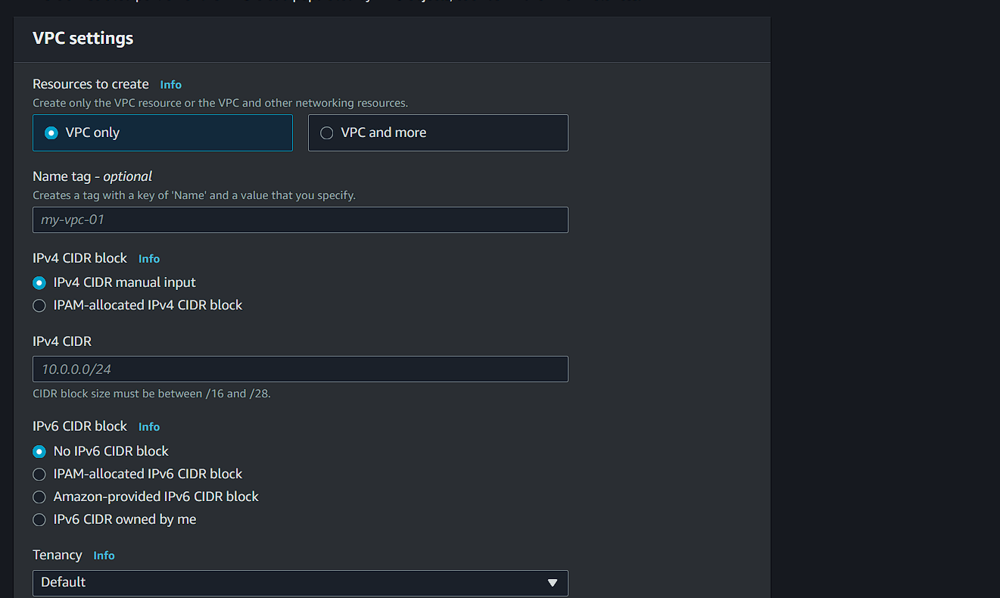

* Enter any name of you wanted
* If we are just launching a VPC select only VPC on top if you wanted any other features select other one.
* Name it and select the IPV4 CIDR block manual input
* Then enter a manual IPV4 CIDR in the text box that was show in the text box as a namespace can be used too.
* Then leave all the configurations to default for a basic creation if you want to try you can change and select others too.
* Then create the VPC by scrolling down
* VPC has been created successfully.

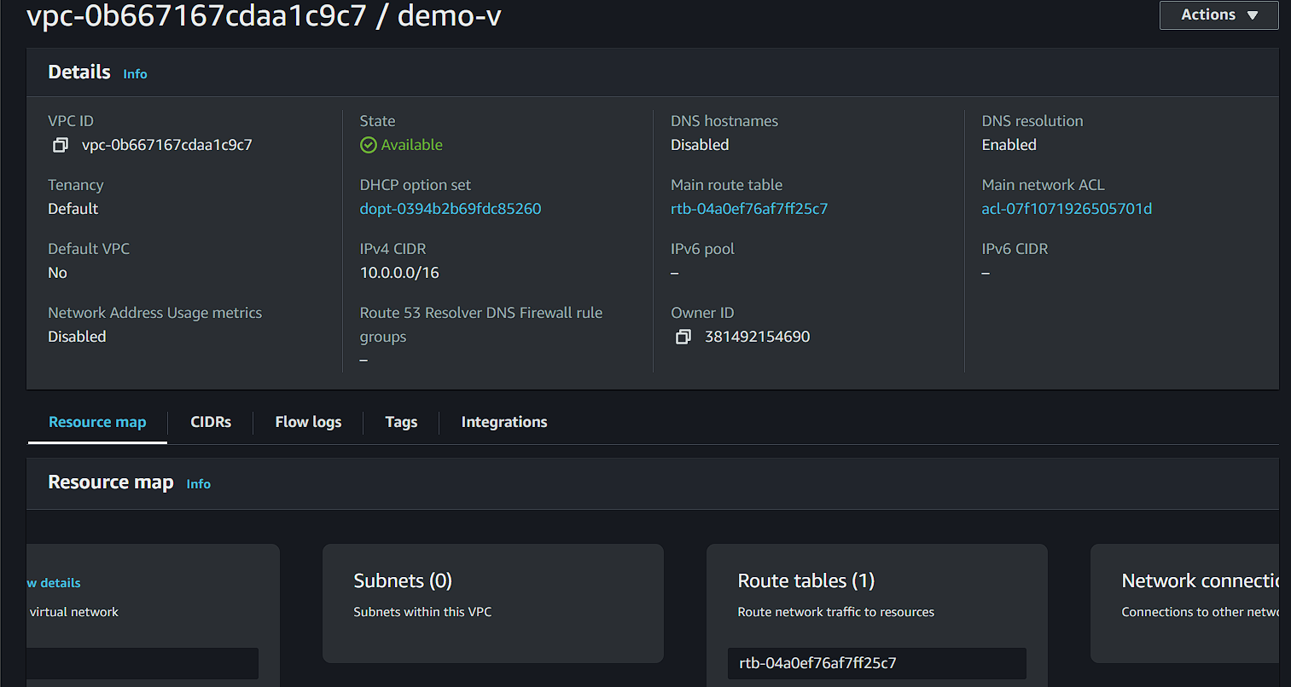

* Now create a subnet for the VPC we have created before.

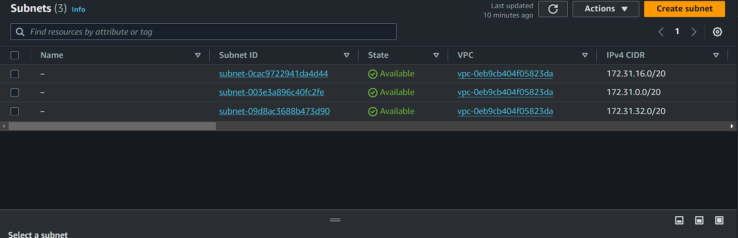

* Start creating the subnet by selecting the VPC that we want to assign it to.

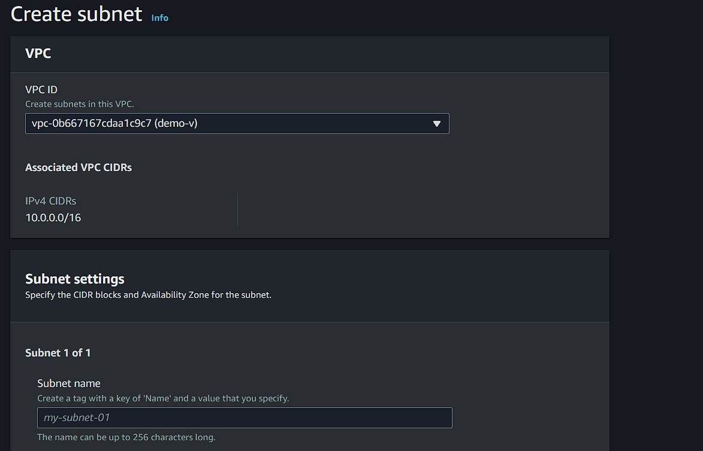

* After selecting the VPC we need to make configurations and then we are ready to create our subnet

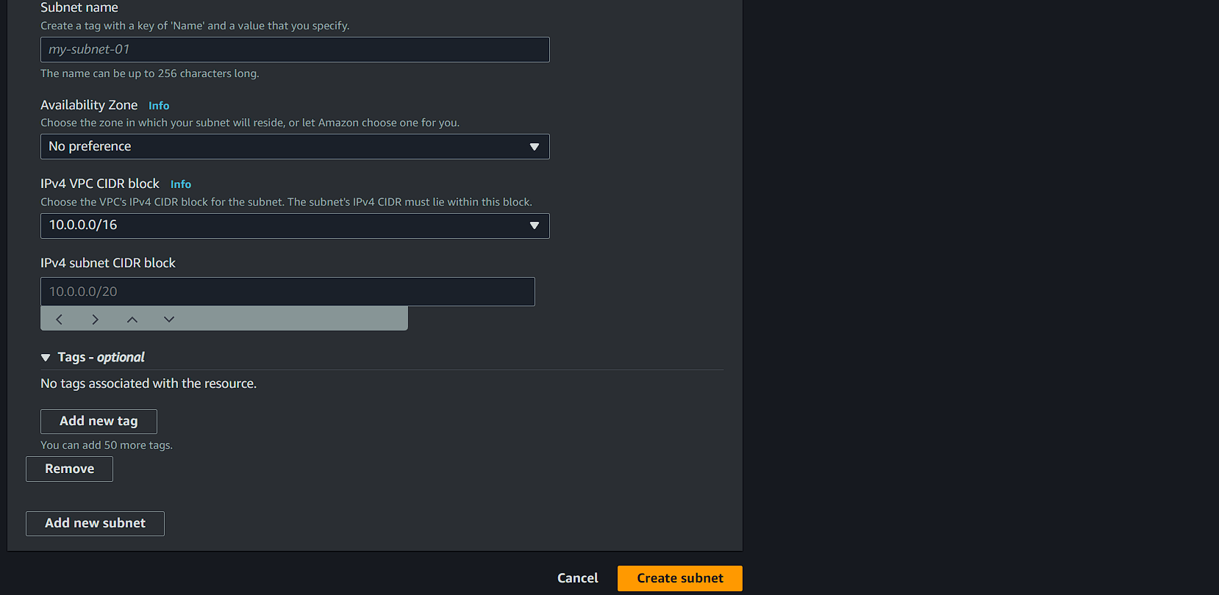

* After configuring the things we are ready launch our subnet and by entering IPV4 CIDR as the basic in show namespace we can get easy access on less thinking.

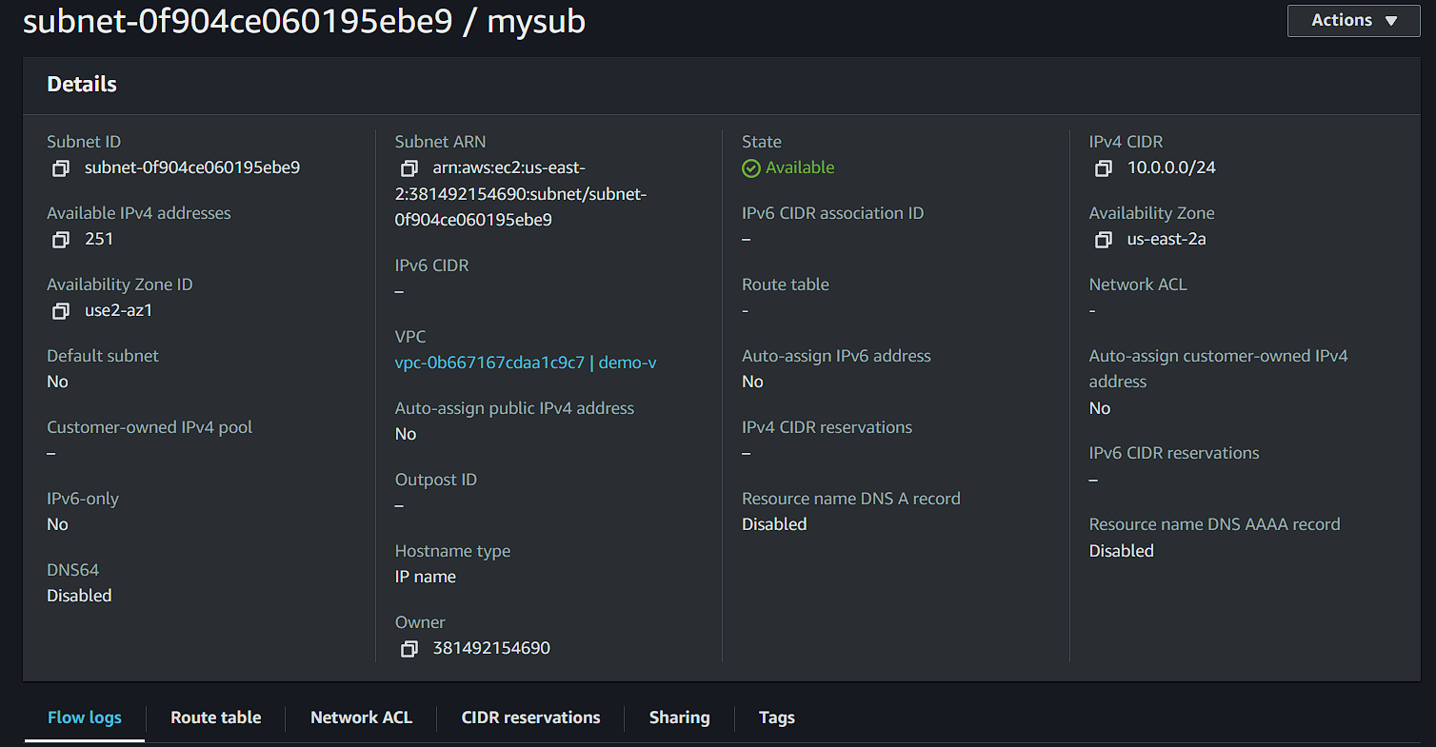

* Let us create internet gateway.

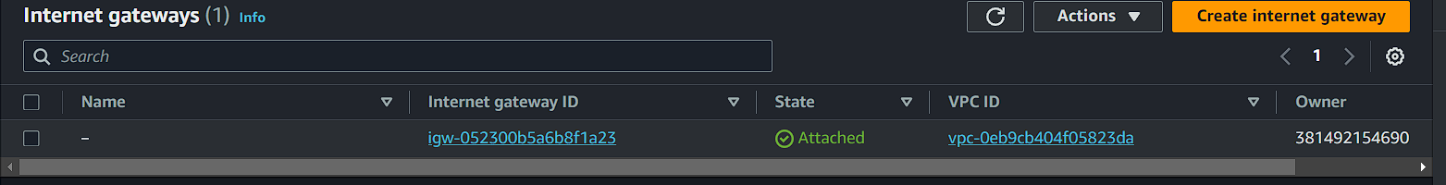

* By just giving name to it, the internet gateway is ready to be created.

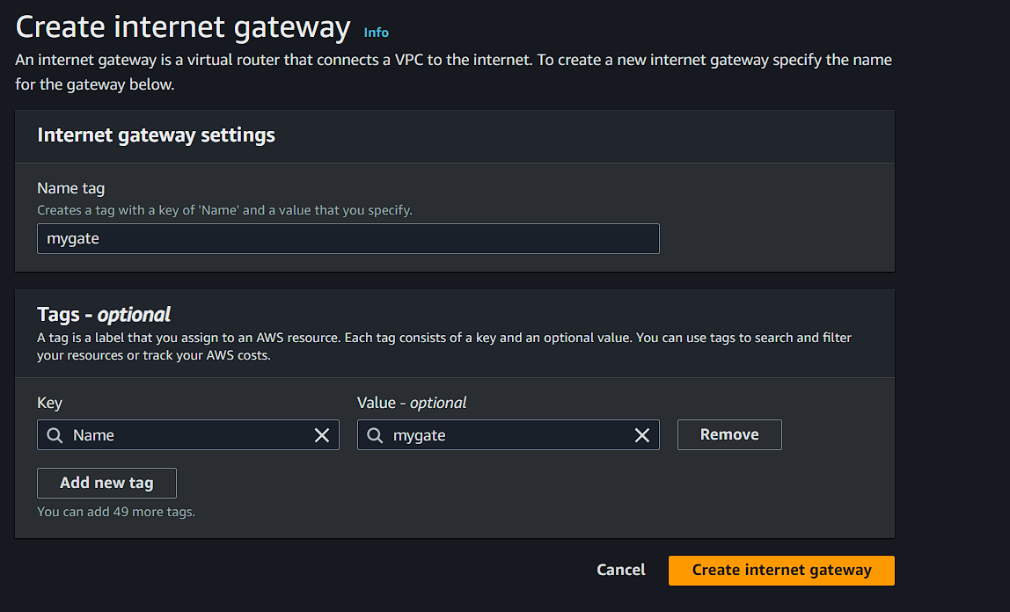

* After creating the gateway we need to connect a VPC for the traffic to be directed to.

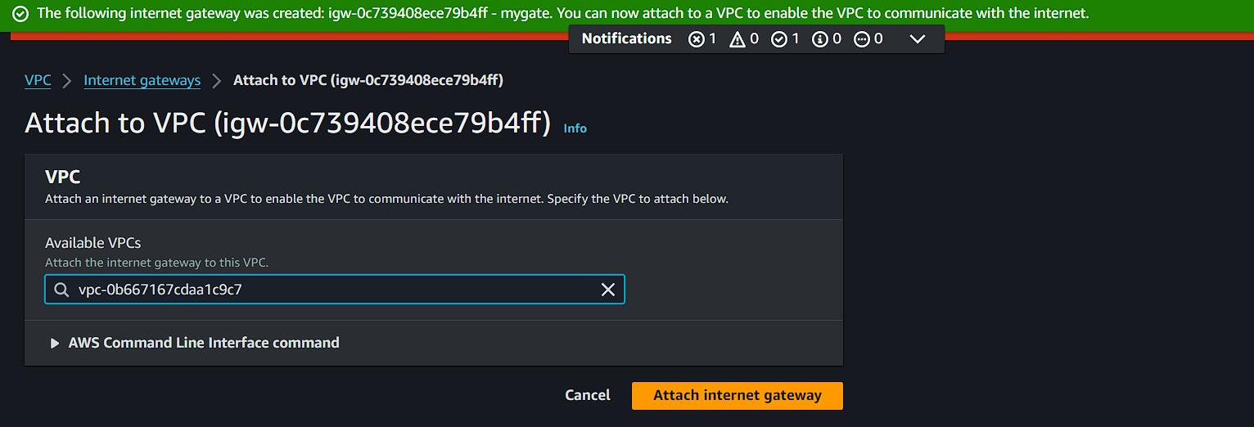

* Now we can see the status as Attached in the internet gateway

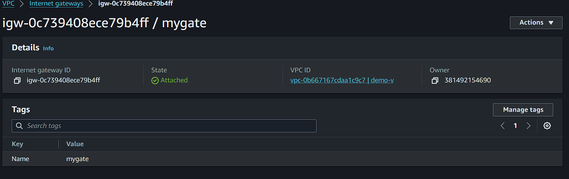

* Now we need to create a route table and assign it to the gateway and the VPC that we have created.
* This all should be done in the creation of route table.

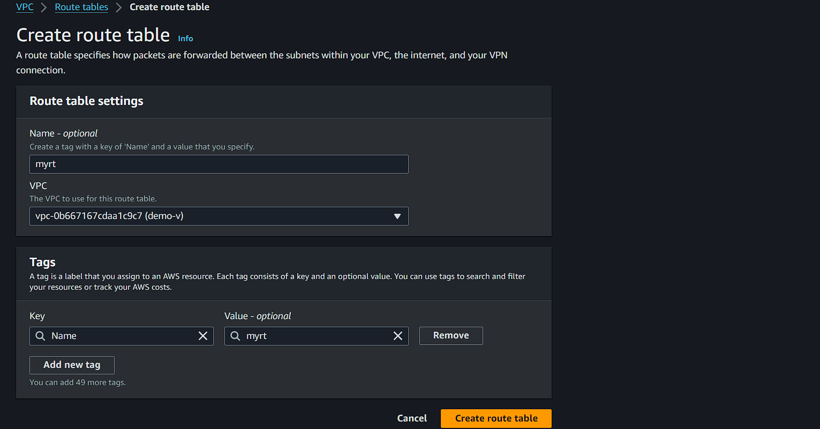

* After creation of route table we have assign or associate the Subnets to the routes

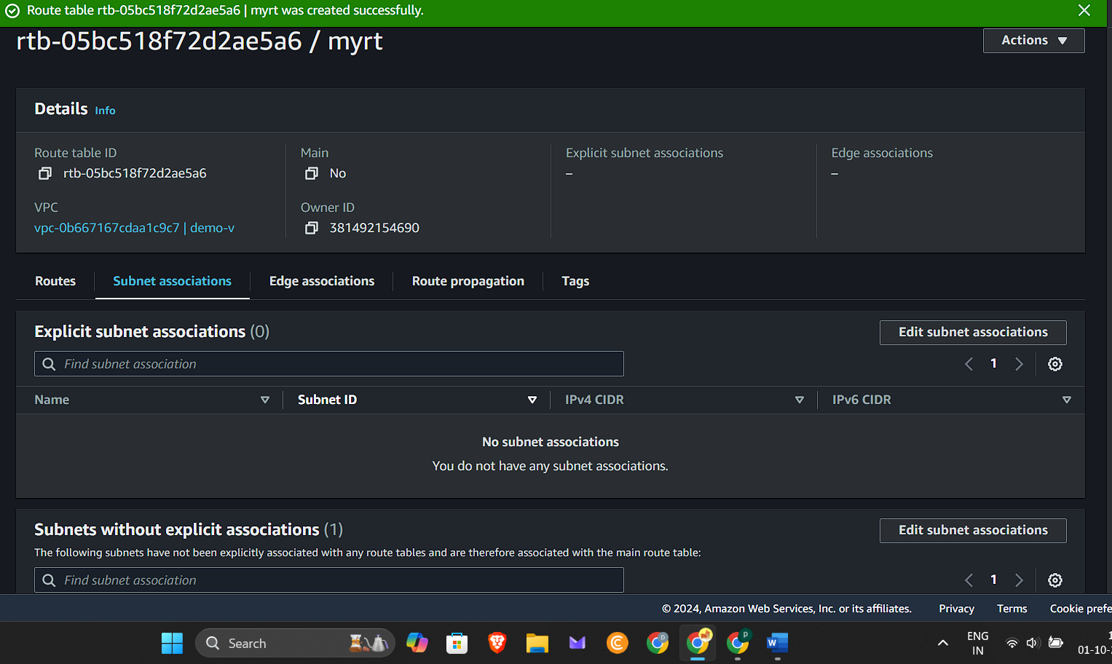

* By scrolling down we can find the subnet association and then clicking on edit we can check and assign the subnet to the route.

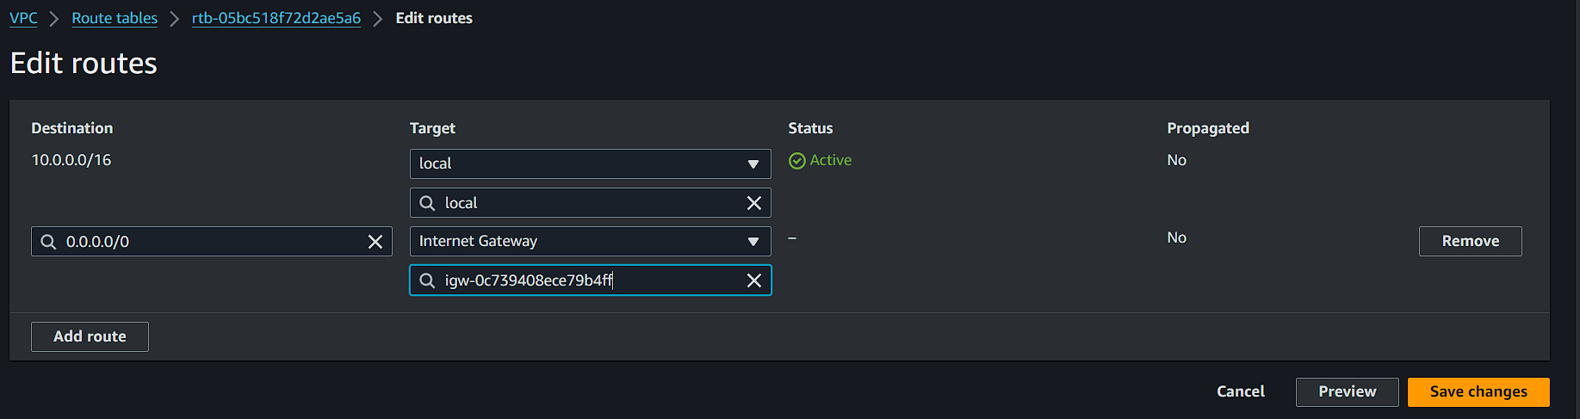

* Now we have to edit the routes and create destination as 0.0.0.0/.0 this will allows the traffic to be anywhere.
* Then select the targets that we have created in internet gateway and we are ready to create.
* After creating the VPC we now need to create a Instance with configuration to the VPC in the network settings
* We have to edit from start and configure all by checking everything.
* After creating the instance now we can revisit the VPC dashboard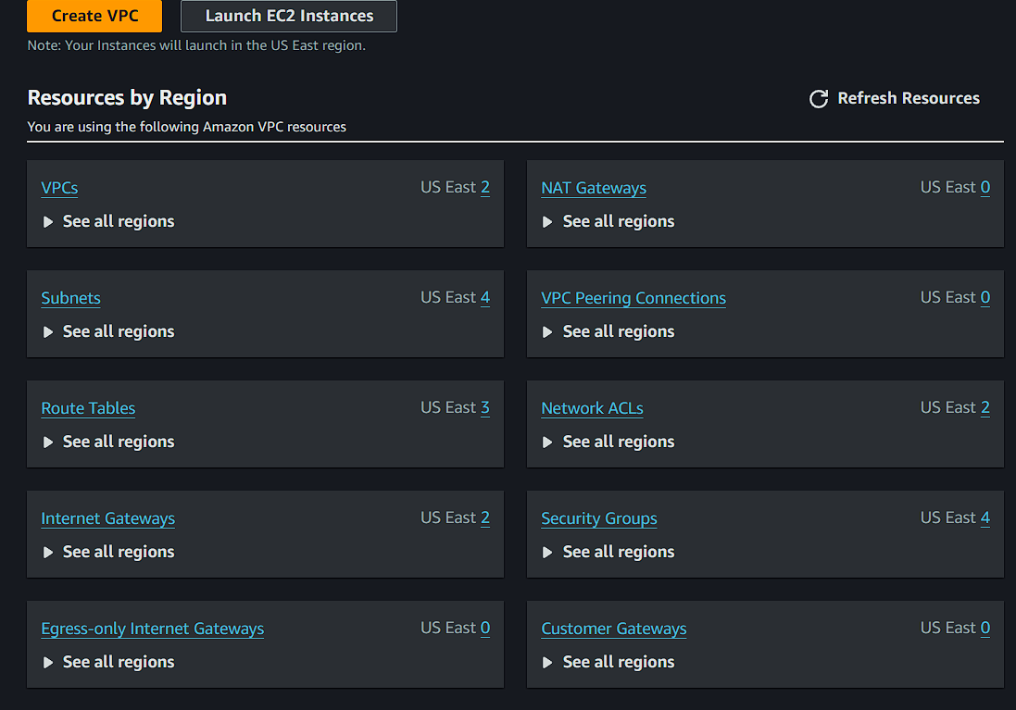
* We can see every info about the network that was used to launch the instance.

**Cloud front:**

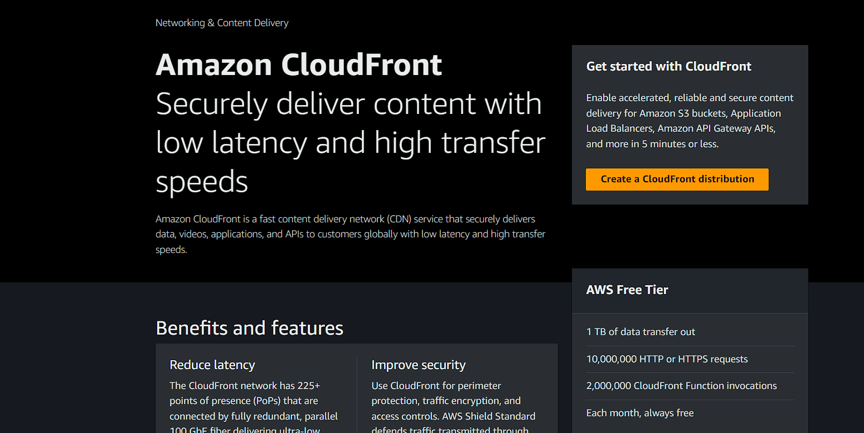

**AWS Cloud formation:**

Aws cloud formation is the service that helps you model and setup your amazon web services resources so that you can spend less time managing those resources and more time focusing on your applications that run in AWS.

Structure of json file :

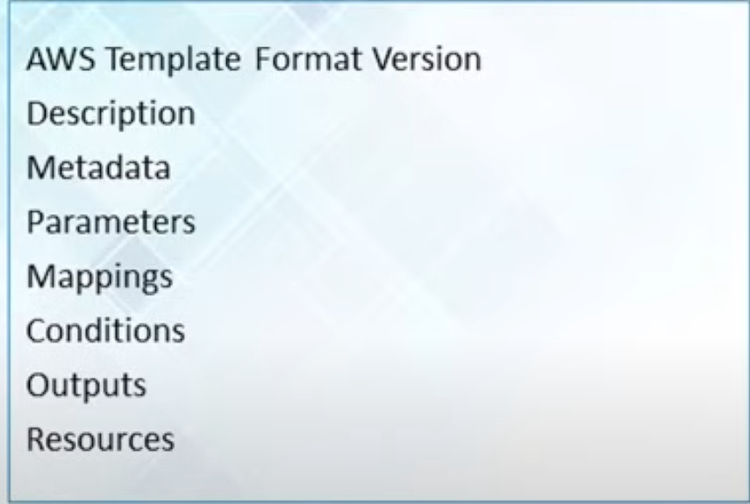

* Search for cloud formation service in AWS console and click on it.
* Start creating a build from a application composer

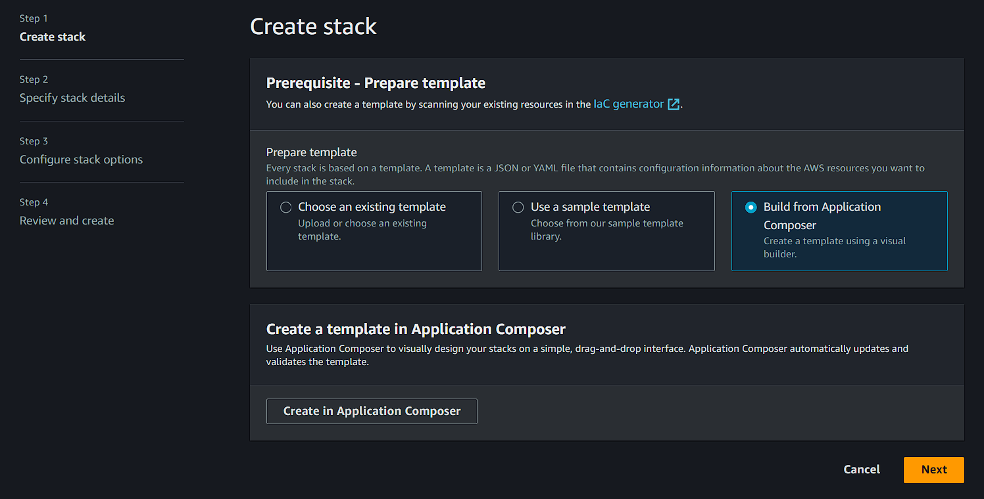

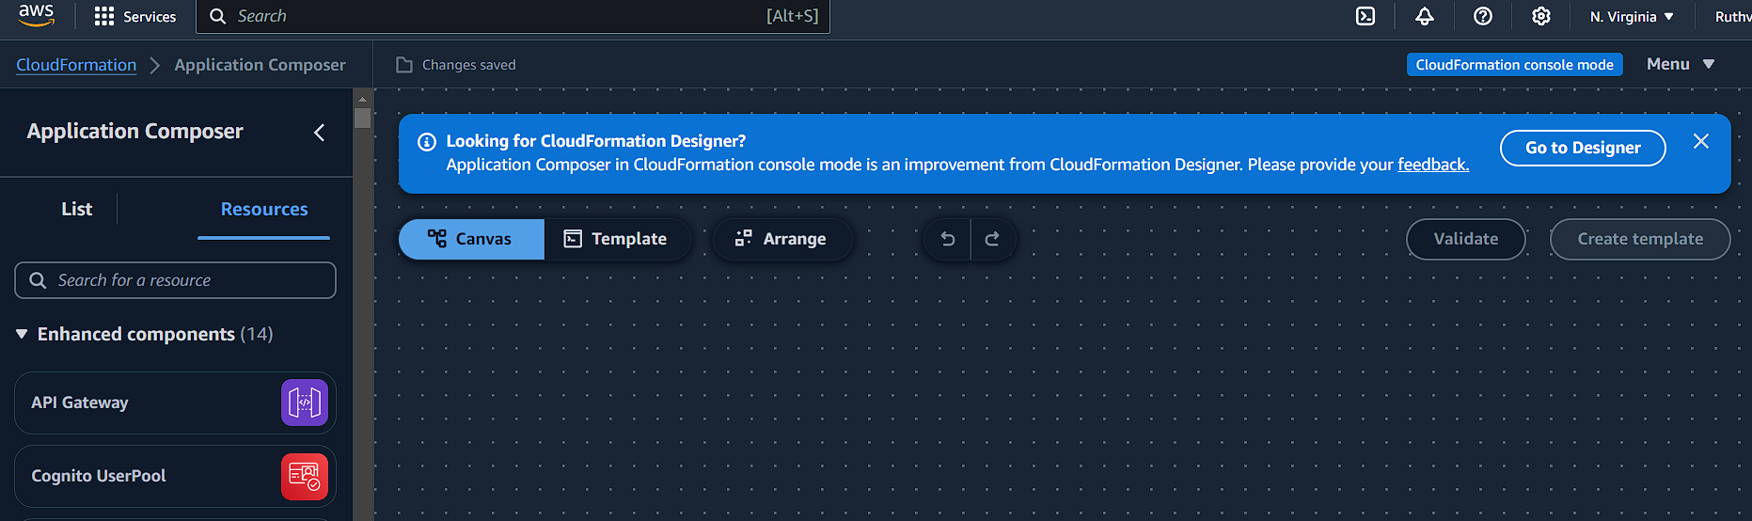

* Now click on go to designer to start creating a application by dragging the needed services.
* After that we can se multiple services that could give us json files for the functions we need to use and implicate.

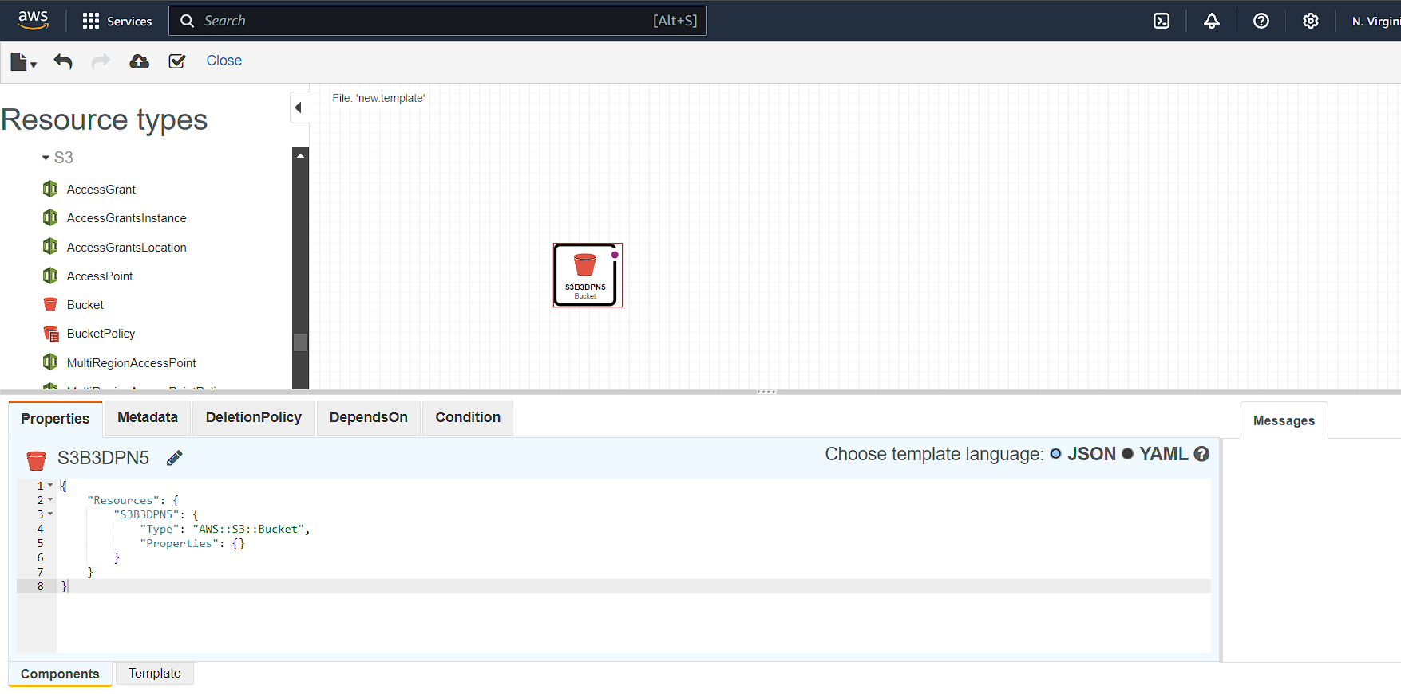

* Here It has shown the json code for the S3 bucket and that code can be used to use the service in the future.

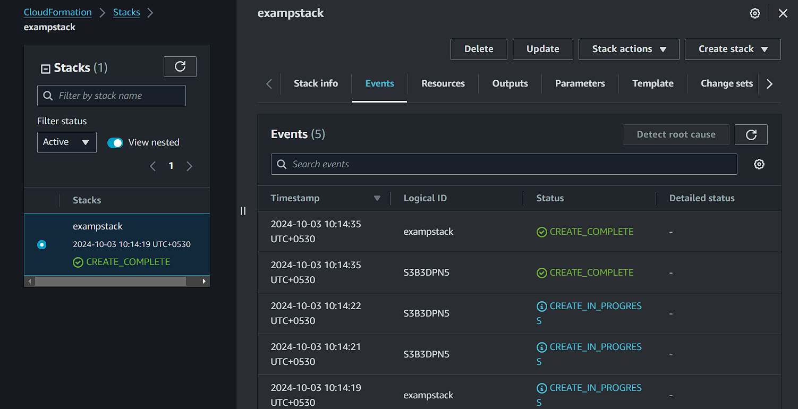

* Template has been created into stack.
* After completing creation we need to check whether the S3 bucket is created or not.

**Snapshots & AMIs**

**Snapshot** only capture data that has been written to your amazon EBS volume at the time the snapshot command is issued

**AMI** is special type of virtual appliance that is used to instantiate a virtual machine within EC2. It serves as the basic unit of deployment for services delivered using EC2.

**Data warehouse**

A data warehouse is a subject-oriented, integrated, time-variant and non-volatile collection of data in support of organisations decision making.

Architecture of Data warehouse:

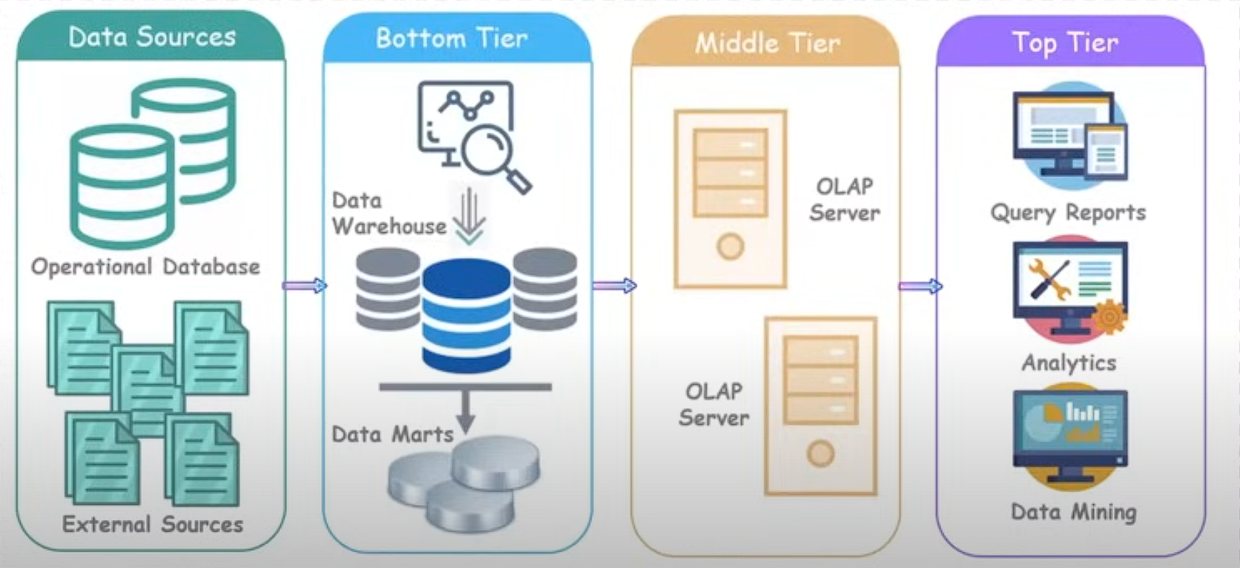

**Application Programming Interface**

**API** is a software that allows two applications to talk to each other.

AWS API Gateway:

It is a service provided by amazon that used to create, publish, maintain, monitor and secure various APIs such as REST(Representational State Transfer), HTTP and webSocket at any scale.